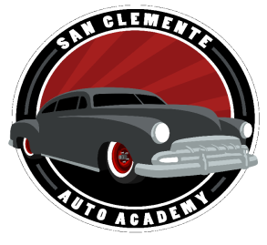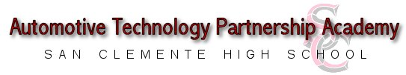

Auto Academy Benefits: | Training May Lead To:
- 3 year progressive training | - Entry level automotive repair jobs
- College Articulation | - College AA degree in automotive technology
- Professional tools updated yearly | - Automotive service advisor
- Hands on experience on newer vehicles | - Parts sales specialist
- Gain knowledge and skills to get the job you want | - Motivation to pursue engineering

Students Learn: | Job Market Information:
- Safety | - Current Demand for technicians is growing
- Introduction to automotive and related careers | - Careers are becoming more advanced
- Service writing and repairing | - Manufacture and private shop openings
- Usage of current service manual systems | - On- the- job paid training & manufacture training
- On board diagnostics | - Entry Level salaries range from $12-$18 per hour.
- Engine and Transmission diagnostics & repair | - Journeyman wages range from $18- $50 per hour depending on specialty and training plus benefits.
- Suspension and chassis repair | 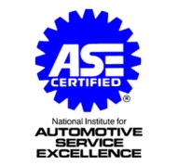
- Performance upgrades
- Hand tool and power tool usage and upkeep

Successful students graduate the Academy with:
A portfolio of work, which includes a certificate for each year of participation, up to 5 industry recognized certificates including ASE’s and a hand written letter of recommendation.
For more information please visit our website at https://sctritons.capousd.org/ and type Auto in the search bar and follow us on Instagram at https://www.instagram.com/schs_auto_academy/
***If you are interested in joining the San Clemente Auto Academy, please complete and return the attached application to room S-11 or email the completed application to your Guidance Counselor.

Academy Admissions Application

Name:______________________________________________________________________________
Parent/Guardian Name:_____________________________________________________________
Address:__________________________________________________________Apt. #____________
City:_________________________________________State:________________Zip:______________
Home Phone:___________________________________Cell Phone:_________________________
Parent e-mail:_______________________________________________________________________

Please check any activities that you have that you may have participated in:
Band/chorus Drama Shop Courses
Community Sports School Service Clubs
School Sports Student Government Other
Foreign Language Community Service
- Please explain why you would like to be a member of this academy:_______________________
__________________________________________________________________________________
__________________________________________________________________________________
- List any hobbies and/or interests you have:___________________________________________
__________________________________________________________________________________
__________________________________________________________________________________
- What is your career goal?:_________________________________________________________
__________________________________________________________________________________
__________________________________________________________________________________
- What do you intend to do after you graduate from San Clemente High School?:______________
__________________________________________________________________________________
__________________________________________________________________________________

Read each statement and check if the activity is something you would like to do often or rarely
OFTEN RARELY
1. | Do you like building things and solving problems?
2. | Do you like checking for accuracy and detail?
3. | Do you wonder how and why things work?
4. | Are you the type of person who likes to fix things?
5. | Do you like to work with people?
6. | Do you like being accurate with information and numbers?
7. | Are you the type of person who likes designing new equipment?
8. | Do you like working with tools?
9. | Do you enjoy performing and demonstrating talents?
10. | Do you like working independently?
11. | Do you like participating in decision-making?
12. | Do you enjoy working with computers?
13. | Do you like working with charts and manuals?
14. | Do you like listening to people and their concerns?

Name of teacher to fill out Student Reference Form __________________________________________

I understand that the Automotive Technology Academy is a three year commitment and I agree to participate fully in all activities and fulfill all requirements.

_______________________________________________ ___________________
Student Signature Date

_______________________________________________ ___________________
Parent Signature Date

Membership is limited in number. Application does not mean automatic acceptance into the Automotive Technology Academy.

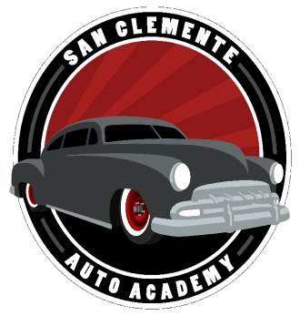
Dear Freshman Students and Parents/Guardians,
We would like to offer you the opportunity to participate in the award winning Automotive Technology Partnership Academy (ATPA). If you are interested in the fields of automotive technology, engineering, electronics, or design, this may be the program for you!
The Automotive Technology Partnership Academy program incorporates the following advantages:
- Students will work with a select group of faculty in a “School-within a School” structure.
- Students will have the opportunity to receive hands-on industry experience.
- Upon completion of the three-year high school program, students will be highly qualified to pursue college programs articulated with the ATPA.
- Students will be challenged through college preparatory classes and advanced technical studies.
- Through competitions, students will have the opportunity to compete for scholarships and awards.

These are the conditions of the Academy:
- Maintain a minimum 2.0 Total GPA
- No “F” grades since entrance into the Academy
- 95% cumulative full-day attendance
- On track for graduation (continually maintain minimum credits for graduation)

If you are interested in being one of the students participating in this exceptional program with classes beginning August 2024, please have your parents sign below and return this letter to the Auto Academy office. Selection will be determined by a faculty interview.

Sean Selff
Lead Instructor/Director
Automotive Technology Partnership Academy

_______________________________________
Students Name (Please Print)

_______________________________________
Parents Signature:

