An Automotive Technician is only as good as their Tools
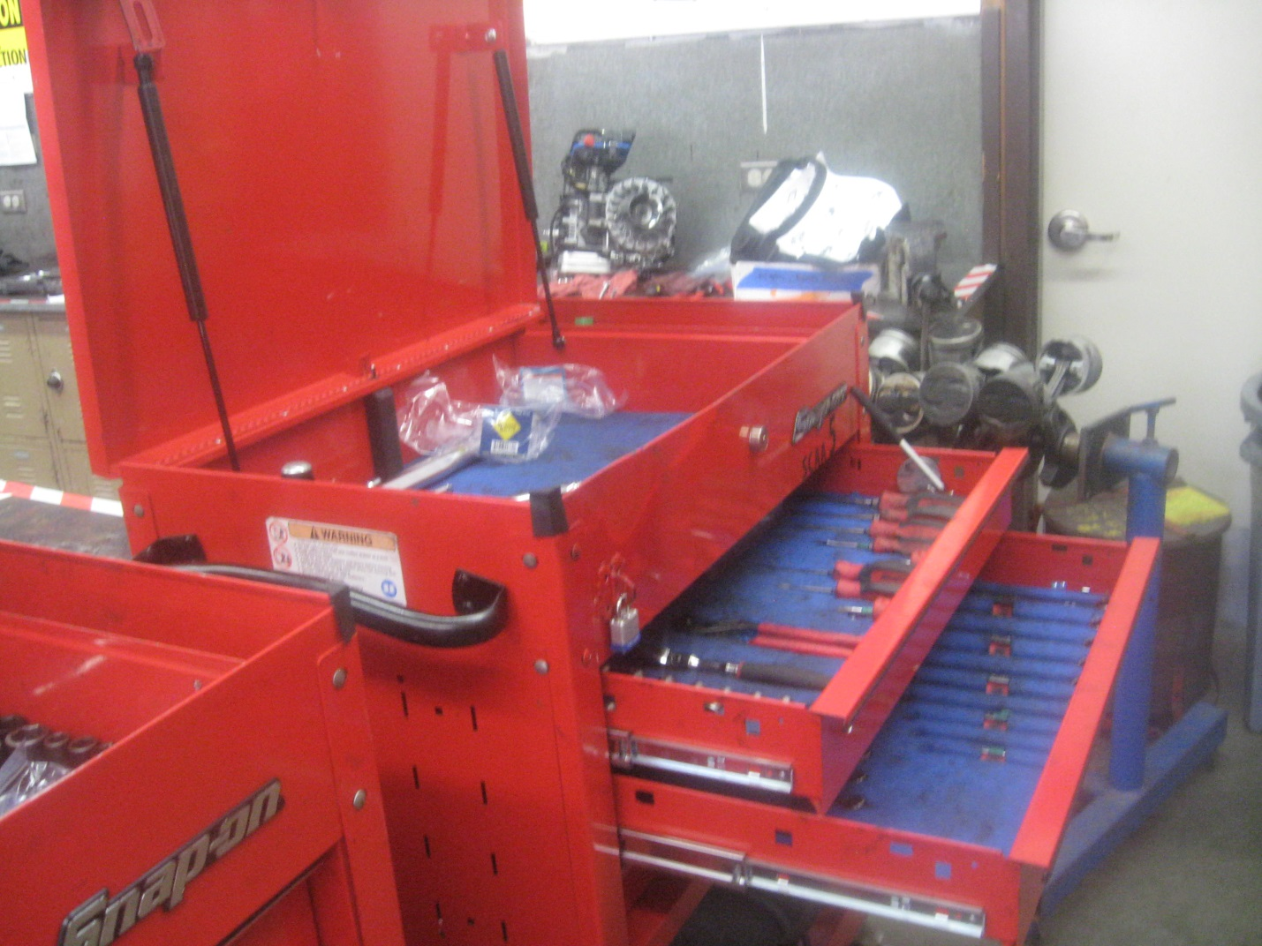
The San Clemente Automotive Technology Partnership Academy accepts donations of industry related tools and equipment to enhance the practical learning experience and performance of our students.
If you have a donation please email us!
nchanson@capousd.org

