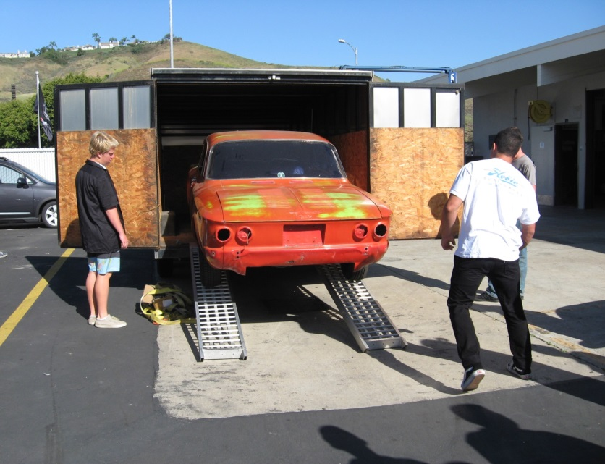

The San Clemente Automotive Technology Partnership Academy accepts donations of cars for hands-on practical student training. Once donated, the car is registered non-operational and never leaves our yard. When the car has completed its use and service, they are then crushed, never sold.
If you would like to donate a car, please email the Academy at nchanson@capousd.org

